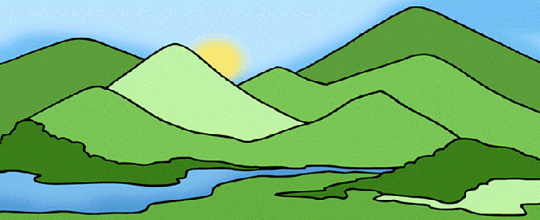

Rome was not built in a day. Rome began as a small village, located on the Italian peninsula in Europe. To be more specific, around 2750 years ago, a tribe of early people settled down in the land of 7 hills, on the Tiber River, near the Mediterranean Sea.
It was a wonderful place to build a town. There was good soil to grow crops. The Tiber River provided a source of fresh water for drinking and bathing. And the 7 hills offered both shelter and a vantage point to keep an eye out for intruders.
Rome grew quickly as a cultural and trade center on the Italian peninsula. Early Roman values included loyalty to the many gods and goddesses they worshiped, loyalty to their family, and obedience to authority. These values produced loyal and obedient subjects, who put their country’s needs and their family’s needs before their own.
Each early Roman family was ruled by the father. His job was to care for his family fairly. The early Roman people were ruled by a king. The king's job was to care for his people fairly.
The early Romans were ruled by kings. The first king was the mythical Romulus, son of the war god Mars. All the kings thereafter claimed they were directly related to Romulus, and that gave them the right to rule.

